Architecture Design Document

Part1. The Input/Output device used in the project
- mark the specific locations of input and output devices on the image of the development board
- attach corresponding explanations for the input and output devices in the system.

Part2. Describe the structure of the project
- Circuit sturcture diagram, clearly marking the 1)input/output ports, 2)the the relationship between top-level module and each submodule, as well as the relationships between submodules.
NOTES: Do NOT use the structure diagram generated by Vivado.
- Explain the functions and the input/output ports of each module in the project.
Here is an example about Rock-Paper-Scissors:

Part3. FSM of the project
- List the states in your project
- Draw the state transition diagram to show the state transmit from one to another

TIPS: Here is an example about part1 and part2 (based on Rock-Paper-Scissors game)
Part1. The Input/Output device used in the project

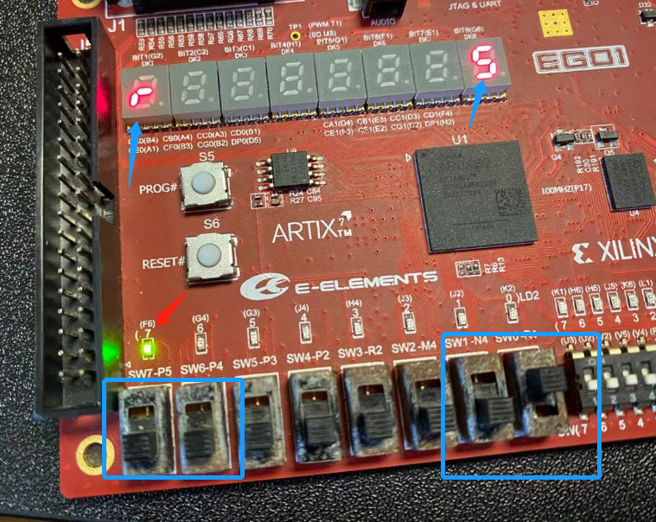

Input device
SW7, SW6 used as Player1’s input, SW7 is MSB, SW6 is LSB
SW1, SW0 used as Player1’s input, SW1 is MSB, SW0 is LSB

Output device1
Led7, led6, led5 used as the result of comparator.
Light Led7 means Player1 win the game;
Light Led5 means Player2 win the game;
Light Led6 means indicates that this is a tie;
Led7, led6, and led5 are all turned off, indicating invalid input.

Output device2
7-segments tub DK1 is used to show the hand gesture of player1
7-segments tub DK8 is used to show the hand gesture of player2
Scissors shows an ‘S’; rock shows an ‘r’ ; paper shows an ‘P’; otherwise shows an ‘E’

Part2. Describe the structure of the project

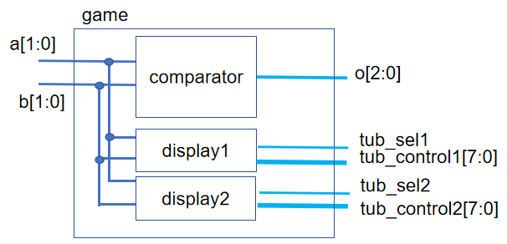
Module name | Input ports | Output ports | Function
game | a[1:0],b[1:0] | o[2:0],tub_sel1,tub_control1[7:0],  tub_sel2,tub_control2[7:0], | Top module
comparator | a[1:0],b[1:0] | o[2:0] | Compare input a and b using Rock-Paper-Scissors rule, show the result of comparator
Display1 | in[1:0] | tub_sel,tub_control1[7:0] | Show the hand gesture of play1 on the 7-seg tub
Display2 | in[1:0] | tub_sel,tub_control1[7:0] | Show the hand gesture of play2 on the 7-seg tub

